Ex. No.: 8
Date:27/01/2023
Joins – EquiJoin, InnerJoin, OuterJoin

Questions:
- List the departments where the faculty members are working.
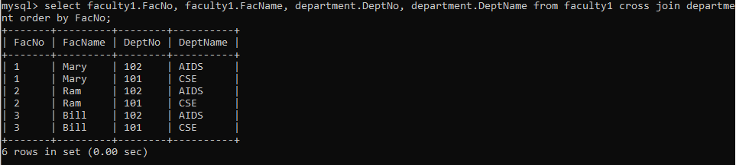

- Find the student who has no score in any of the courses. List student name and course number.
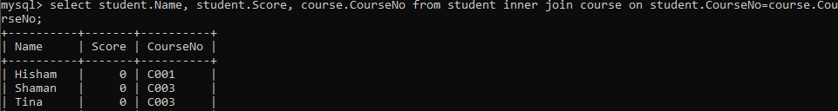

- The office clerk needs the names of the courses taken by the faculty belonging to ‘ECE department’ whose name is ‘Kamal’

